Week 2
Session 6 -Functional Programming using map()
- Shuffle the Array
PROGRAM
class Solution {
public int[] shuffle(int[] nums, int n) {
// Create a result array of size 2n
int[] result = new int[2 * n];

// Loop through the first half of the array
for (int i = 0; i < n; i++) {
// Place the x elements at even indices
result[2 * i] = nums[i];
// Place the y elements at odd indices
result[2 * i + 1] = nums[n + i];
}

return result;
}
}

OUTPUT
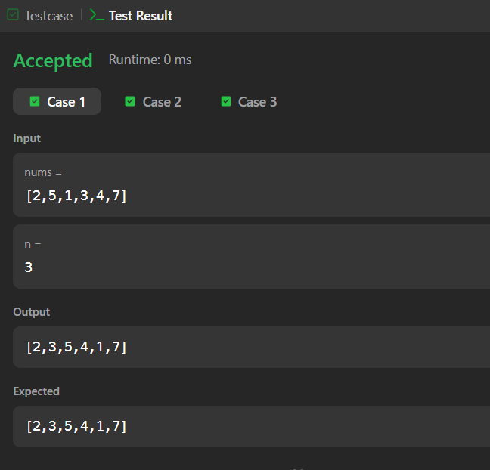
Session 7 - Functional Programming using filter()
- Remove Element
PROGRAM
class Solution {
public int removeElement(int[] nums, int val) {
int k = 0; // Pointer to track the position of valid elements

for (int i = 0; i < nums.length; i++) {
// If the current element is not the value we want to remove
if (nums[i] != val) {
nums[k] = nums[i]; // Move it to the front of the array
k++; // Increment the count of valid elements
}
}

return k; // Return the total number of elements not equal to val
}
}

OUTPUT
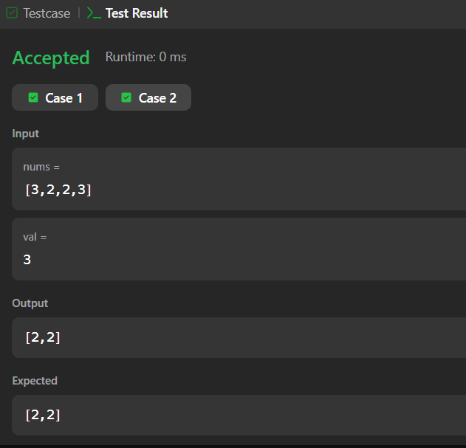

- Remove Duplicates from Sorted Array
PROGRAM
class Solution {
public int removeDuplicates(int[] nums) {
if (nums.length == 0) {
return 0;
}

// Pointer for the location of the last unique element found
int k = 1;

// Iterate through the array starting from the second element
for (int i = 1; i < nums.length; i++) {
// If current element is different from the previous unique element
if (nums[i] != nums[i - 1]) {
nums[k] = nums[i]; // Move it to the unique position
k++; // Increment the count of unique elements
}
}

return k; // Return the total number of unique elements
}
}

OUTPUT
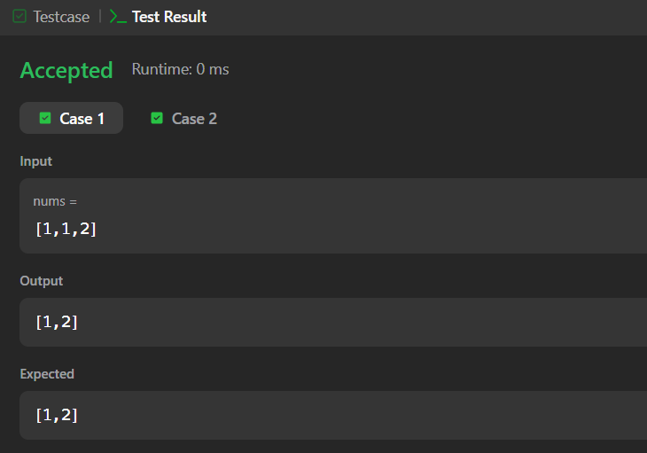

Session 8 - Functional Programming using reduce()
- Maximum Subarray
PROGRAM
class Solution {
public int maxSubArray(int[] nums) {
int currentSum = nums[0];
int maxSum = nums[0];

for (int i = 1; i<nums.length; i++) {
currentSum = Math.max(nums[i], currentSum + nums[i]);
maxSum = Math.max(maxSum, currentSum);
}
return maxSum;
}
}
OUTPUT

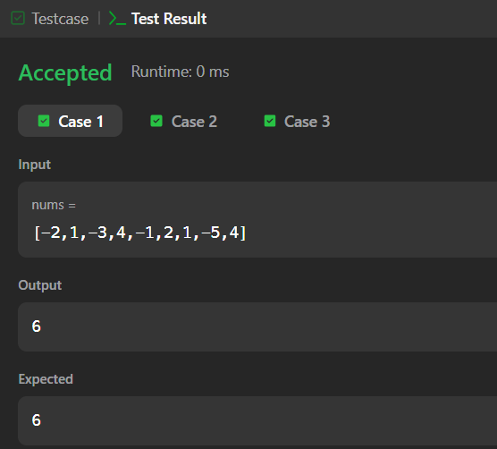
- Find the Highest Altitude
PROGRAM
class Solution {
public int largestAltitude(int[] gain) {
int maxAltitude = 0;
int currentAltitude = 0;

// Traverse through each net gain value
for (int i = 0; i < gain.length; i++) {
currentAltitude += gain[i];

// Track the maximum altitude reached so far
if (currentAltitude > maxAltitude) {
maxAltitude = currentAltitude;
}
}

return maxAltitude;
}
}

OUTPUT
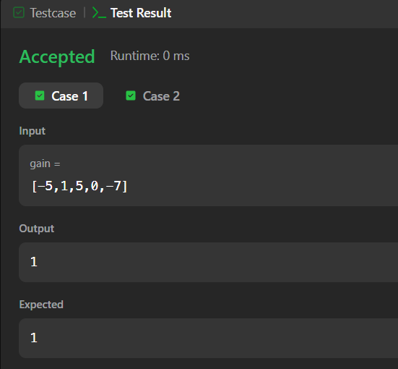

Session 9- Stream & Pipeline Processing
- Group Anagrams
PROGRAM
import java.util.ArrayList;
import java.util.Arrays;
import java.util.HashMap;
import java.util.List;
import java.util.Map;

class Solution {
public List<List<String>> groupAnagrams(String[] strs) {
// Handle boundary case for empty input array
if (strs == null || strs.length == 0) {
return new ArrayList<>();
}

// Map to store the sorted string as key and the list of anagrams as value
Map<String, List<String>> map = new HashMap<>();

for (String str : strs) {
// Convert string to character array to sort it
char[] charArray = str.toCharArray();
Arrays.sort(charArray);

// The sorted character array becomes the common key for all anagrams
String key = String.valueOf(charArray);

// If the key is not present, initialize a new list
map.computeIfAbsent(key, k -> new ArrayList<>()).add(str);
}

// Return all grouped lists from the map values
return new ArrayList<>(map.values());
}
}

OUTPUT
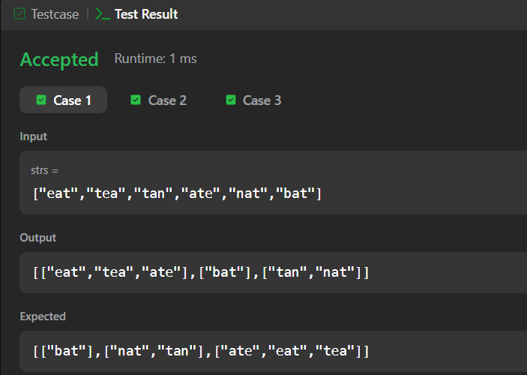

- Top K Frequent Elements
PROGRAM
import java.util.*;

class Solution {
public int[] topKFrequent(int[] nums, int k) {
// Step 1: Count the frequency of each element
Map<Integer, Integer> frequencyMap = new HashMap<>();
for (int num : nums) {
frequencyMap.put(num, frequencyMap.getOrDefault(num, 0) + 1);
}

// Step 2: Create buckets where index represents the frequency
// The maximum possible frequency is nums.length
List<Integer>[] bucket = new ArrayList[nums.length + 1];

for (int key : frequencyMap.keySet()) {
int frequency = frequencyMap.get(key);
if (bucket[frequency] == null) {
bucket[frequency] = new ArrayList<>();
}
bucket[frequency].add(key);
}

// Step 3: Gather the top K frequent elements by iterating backwards
int[] result = new int[k];
int index = 0;

for (int pos = bucket.length - 1; pos >= 0 && index < k; pos--) {
if (bucket[pos] != null) {
for (int num : bucket[pos]) {
result[index++] = num;
if (index == k) {
return result;
}
}
}
}

return result;
}
}
OUTPUT
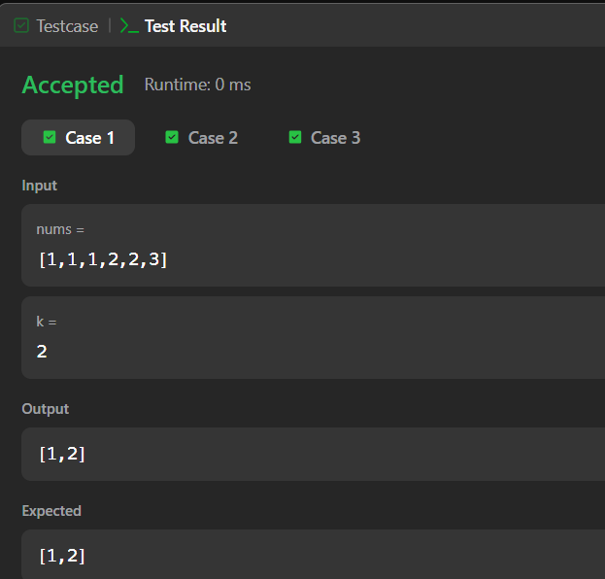

Session 10 - Stream API & Collection Processing
- JAVA DEQUEUE
PROGRAM
import java.util.Scanner;
import java.util.ArrayDeque;
import java.util.Deque;
import java.util.HashSet;
import java.util.Set;

public class test {
public static void main(String[] args) {
Scanner in = new Scanner(System.in);
Deque<Integer> deque = new ArrayDeque<>();
Set<Integer> set = new HashSet<>();

int n = in.nextInt();
int m = in.nextInt();
int maxUnique = 0;

for (int i = 0; i < n; i++) {
int num = in.nextInt();

// Add current element to both tracking collections
deque.addLast(num);
set.add(num);

// When the window size reaches 'm'
if (deque.size() == m) {
// Track the maximum unique count found so far
if (set.size() > maxUnique) {
maxUnique = set.size();
}

// If maximum possible unique elements are found, we can optimize and exit early
if (maxUnique == m) {
break;
}

// Slide the window: remove the oldest element
int firstRemoved = deque.removeFirst();

// Only remove from the unique set if it doesn't appear elsewhere in the current window
if (!deque.contains(firstRemoved)) {
set.remove(firstRemoved);
}
}
}

in.close();
System.out.println(maxUnique);
}
}

OUTPUT

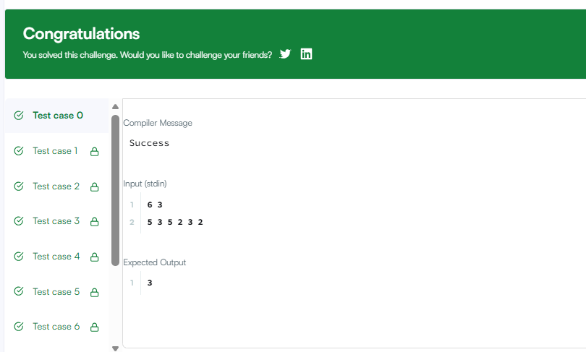

- Java Hashset
PROGRAM
import java.io.*;
import java.util.*;
import java.text.*;
import java.math.*;
import java.util.regex.*;

public class Solution {

public static void main(String[] args) {
Scanner s = new Scanner(System.in);
int t = s.nextInt();
String [] pair_left = new String[t];
String [] pair_right = new String[t];

for (int i = 0; i < t; i++) {
pair_left[i] = s.next();
pair_right[i] = s.next();
}
//Write your code here
HashSet<String> set = new HashSet<>();

for (int i = 0; i < t; i++) {
set.add(pair_left[i] + " " + pair_right[i]);
System.out.println(set.size());
}

}
}

OUTPUT

